SnapFect Technology

Transfection (Nucleic Acids) - A Delivery Problem
Transfection: The process of delivering foreign Nucleic Acids into Cells
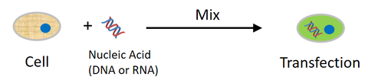
The Problem: Based on electrostatics (negative charged cells and negative charged Nucleic Acids)
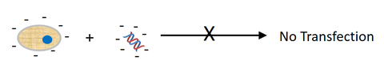
The Solution:
- Make a high positive charge complex of lipids or polymer with nucleic acids.
- The high positive charge complex adheres to negatively charged cells
All commercial products are based on this electrostatic principle – problem: highly toxic – low viability and efficiency.
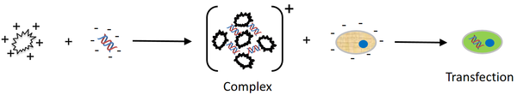

Transfection using Bio-orthogonal Directed Delivery of Nucleic Acids - SnapFect
(Low toxicity – High Viability – High Efficiency)
